Portfolio

|  |  |
| --- | --- |
|  | H:\Projects\P27 not counted\Pcitures\With Diffuser\Velocity_120.png |
| D:\QuadCopter_Project\velocity.pngH:\Projects\P27 not counted\Pcitures\7.pngH:\Projects\P13\contours\contours\ice pressure.jpg | D:\QuadCopter_Project\FFF.png |
|  |  |

*Usama Malik*

*BS. Aerospace Engineering (TU Delft, Netherlands).*

*MS. Aerospace Engineering (IST, Pakistan).*

*Specialization Aerodynamics / CFD.*

Contents

[Introduction 2](#_Toc160135112)

[Project: Aero-Kit analysis on GOLF MK7 and SUPRA MK5 3](#_Toc160135113)

[Project: Analysis on Ahmed Body with and without Diffuser 3](#_Toc160135114)

[Project: Aerodynamic analysis on Spoiler of car 4](#_Toc160135115)

[Project: Ice modeling on wings (A320) at 35000 Feet 4](#_Toc160135116)

[Project: Gas turbine exhaust Diffuser analysis 5](#_Toc160135117)

[Project: Solid flow erosion 7](#_Toc160135118)

[Project: Heat transfer analysis of bacterial growth instrument 8](#_Toc160135119)

[Project: Structural Analysis on Accelerator 10](#_Toc160135120)

[Project: Sloshing phenomenon using VoF (multiphase) 10](#_Toc160135121)

[Project: Cold flow and condensation problem analysis 12](#_Toc160135122)

[Project: Wind Turbine Analysis 12](#_Toc160135123)

[Project: Quadcopter Analysis 14](#_Toc160135124)

[Figure 1: Aerodynamic Analysis on Supra MK5 3](#_Toc160135125)

[Figure 2: Aerodynamic Analysis on GOLF MK7 3](#_Toc160135126)

[Figure 3: Ahmed body with diffuser 3](#_Toc160135127)

[Figure 4: Spoiler analysis 4](#_Toc160135128)

[Figure 5: Spoiler (DownForce vs Speed) 4](#_Toc160135129)

[Figure 6: Ice formation and thickness of ice on required surface 5](file:///F:\Projects\Portfolio\Usama_Malik_CFD.docx#_Toc160135130)

[Figure 7: Clockwise from top left (a) and (b) velocity streamlines. (c) Pressure contour (d) velocity contours 6](#_Toc160135131)

[Figure 8: a: Basic structure of both filters b: Two types of filters selected for Analysis c: Configuration 1 CAD model, made using CREO 6.0 d: Configuration 2 CAD model, made using CREO 6.0 7](#_Toc160135132)

[Figure 9: Clockwise from top left Configuration 1 Pressure Drop contours, Configuration2 Pressure Drop contours, Configuration 1 Velocity Streamlines, Configuration 2 Velocity Streamlines 8](#_Toc160135133)

[Figure 10: Instrument CAD model. Between 1 and 3 is bacteria film and beneath 1 is the heat source. 9](#_Toc160135134)

[Figure 11: Mesh of the model made using ANSYS inbuilt mesher 9](#_Toc160135135)

[Figure 12: Steady-state temperature contours of instrument. 9](#_Toc160135136)

[Figure 13: Steady-state temperature contours at bacteria film 10](file:///F:\Projects\Portfolio\Usama_Malik_CFD.docx#_Toc160135137)

[Figure 14: Composite car accelerator 10](#_Toc160135138)

[Figure 15: Compartment without baffles 11](#_Toc160135139)

[Figure 16: Compartment without baffles 11](#_Toc160135140)

[Figure 17: Condensation rate visible, red with most and blue with least condensation rate. Note the increased condensation rate at top center where steam impinges most. 12](file:///F:\Projects\Portfolio\Usama_Malik_CFD.docx#_Toc160135141)

[Figure 18: Note the difference of condensation rates between copper pipes and steel plates. 12](file:///F:\Projects\Portfolio\Usama_Malik_CFD.docx#_Toc160135142)

[Figure 19: Mesh generated in Ansys of wind turbine. Second picture shows the analysis. 13](#_Toc160135143)

[Figure 20: Mesh of 3 turbines along with the velocity contours in the second figure. 13](#_Toc160135144)

[Figure 21: Stream lines of 3 wind turbine at a yaw angle and second figure shows the velocity contours. 13](#_Toc160135145)

[Figure 22: Streamlines of 7 turbines simulated in Ansys 14](#_Toc160135146)

[Figure 23: Mesh of 2 blade propeller 14](#_Toc160135147)

[Figure 24: Streamlines 15](#_Toc160135148)

[Figure 25: Streamlines along the propeller blade 15](#_Toc160135149)

# Introduction

I am Usama Malik. I am an Aerospace Engineer. I have done Masters in Aerospace Engineering from one of the prestigious universities in Pakistan. My bachelors is from Delft University of Technology (TU Delft), Netherlands.

As an Aerospace Engineer with a profound dedication to computational fluid dynamics (CFD) and finite element analysis (FEA), I am driven by a relentless pursuit of challenging projects that foster professional growth and contribute meaningfully to society. With a robust academic background from esteemed institutions in Pakistan and the Netherlands, coupled with hands-on experience gained through freelance engagements and industry collaborations, I possess a diverse skill set and a passion for innovation in Aerospace engineering.

**Computational Fluid Dynamics**

I have done many projects in my bachelors and in masters degree program. All my projects have been related to CFD and FEA. For quite some time now I have been working freelance work along with my job. It helps me to do some exciting projects along with my daily routine. I do projects which helps me to grow professionally and where I feel that my contribution would do good. I help CFD society with their problems. Below is the list in which I have expertise:

* Steady state and transient CFD simulations of internal/external liquid and gas flows
* Optimal turbulence modeling approaches: RANS, URANS, RSM, LES, DES
* Rotating equipment and moving bodies
* Fluid-structure interaction
* Multiphase and free surface flows
* Analysis, design and optimization of immersed or surrounding components
* Incompressible, transonic and compressible flows
* Heat transfer and thermal modeling
* Flow mixing

Throughout my career, I have undertaken a multitude of projects spanning various domains within aerospace engineering, with a focus on CFD and FEA applications. While some project specifics are bound by non-disclosure agreements, here are select highlights from recent endeavors:

* Conducting drag assessments for ground vehicles, ships, and aircraft through virtual wind tunnel simulations using ANSYS software.
* Validating wind loads on structures and ensuring comfort in urban environments.
* Predicting snow buildup on aircraft surfaces to optimize operational safety and efficiency.

With a steadfast commitment to excellence and a proven track record of delivering impactful solutions, I am poised to tackle complex aerospace engineering challenges with confidence and ingenuity. My portfolio reflects a dedication to advancing the field of computational fluid dynamics and finite element analysis, driven by a genuine passion for pushing the boundaries of technological innovation in service to society.

# Project: Aero-Kit analysis on GOLF MK7 and SUPRA MK5

The comparative analysis focused on enhancing the aerodynamic performance of two iconic automotive models, the VOLKSWAGEN GOLF MK7 and the Toyota SUPRA MK5. The study meticulously evaluated the impact of various aero-enhancements, including distinct wing designs, front splitters, and diffusers, on both vehicles to quantify changes in downforce and drag coefficients. Ultimately, this comprehensive analysis contributes to the body of knowledge surrounding automotive aerodynamics, offering valuable insights for enthusiasts, engineers, and industry professionals seeking to optimize the performance and driving experience of iconic vehicles.

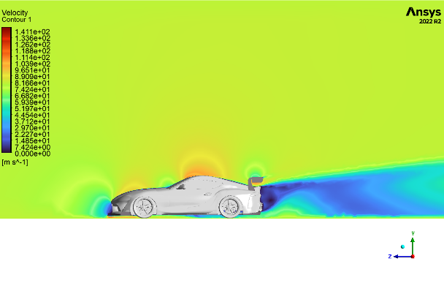

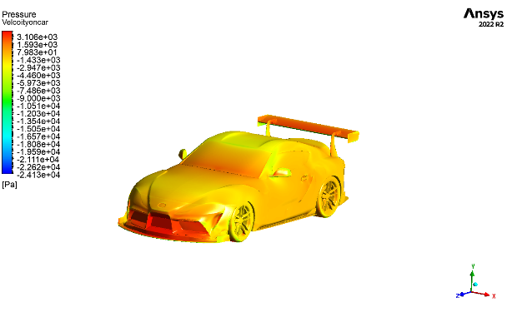

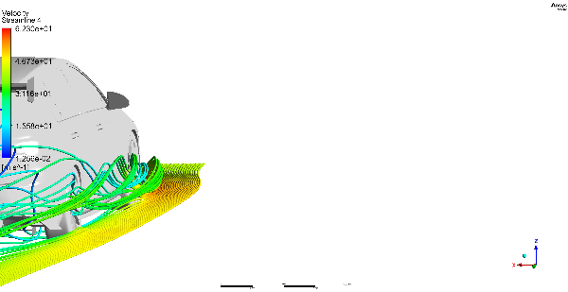Figure : Aerodynamic Analysis on Supra MK5

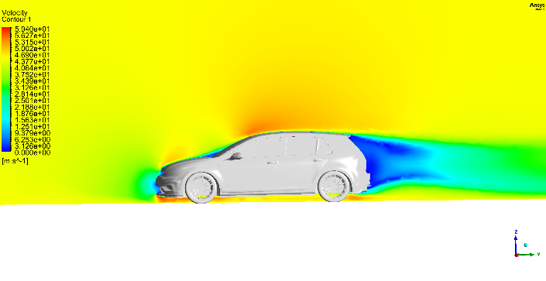

Figure : Aerodynamic Analysis on GOLF MK7

# Project: Analysis on Ahmed Body with and without Diffuser

Ahmed body is simplified vehicle model. One of my client wanted to capture the airflow around the Ahmed body using the diffuser he designed. Boundary conditions were provided by the client and simulation was conducted. The drag and lift effects were observed during the analysis at different speeds. Results were compared with the Ahmed body without the diffuser. The effect of diffuser was clearly seen in the results.

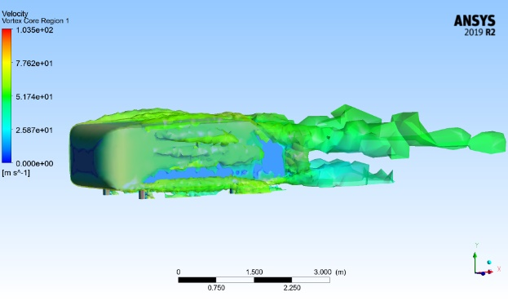 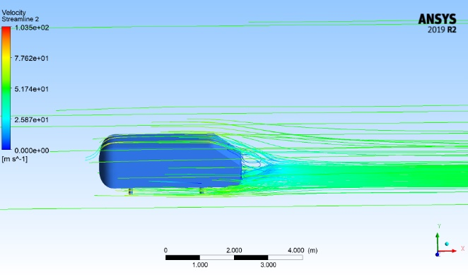

Figure 3: Ahmed body with diffuser

# Project: Aerodynamic analysis on Spoiler of car

Being an Aerospace engineer I have simulated many wings for analyzing their lift and drag. This project was aimed for a modified car. One of my clients modify the car for his clients. To give them proper specification of his products he conducted aero analysis of his designed spoiler on different angle of attacks at different speeds. The project stated above was also from the same client.

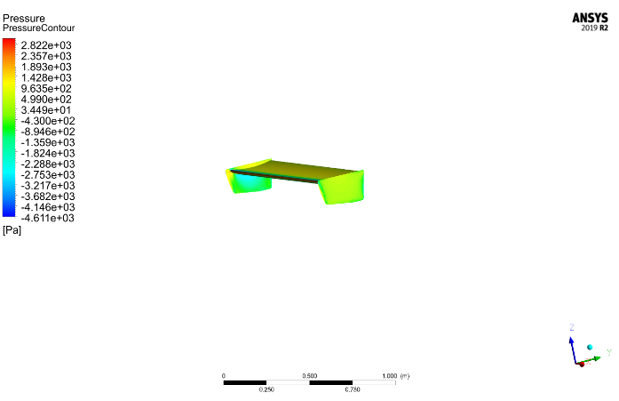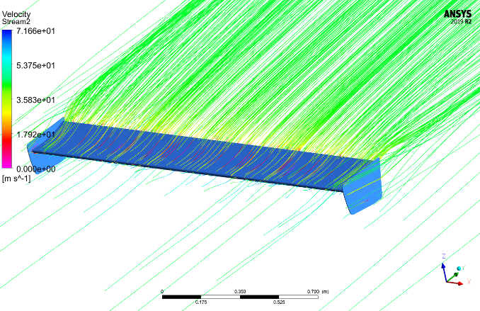

Figure 4: Spoiler analysis

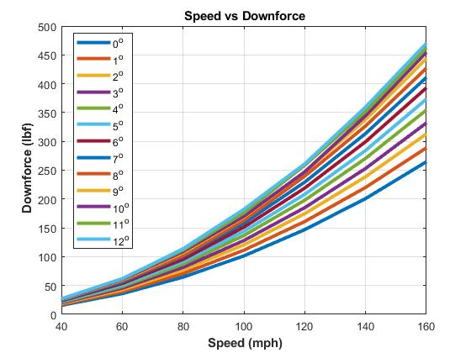

Figure 5: Spoiler (DownForce vs Speed)

Project: Ice modeling on wings (A320) at 35000 Feet

In-flight aircraft icing simulation was performed using FENSAP-ICE. An aircraft wing cruising at an altitude of 16000 ft with a velocity of 0.7 Mach. ANSYS Fluent was used to perform steady state Air-flow simulation before ice modeling was performed. FENSAP-ICE uses Fluent results to perform ice modeling. Ice modeling is performed in two steps.

* Solution for droplets formation at required surface is calculated.
* Solution for phase-change of these droplets formation is calculated.

Furthermore, when ice is formed on an aircraft surface, effective shape of wings and other surfaces change, which results in lift reduction and increased drag. Calculation of increase in drag and decrease in lift require air-flow simulation before and after ice formation.

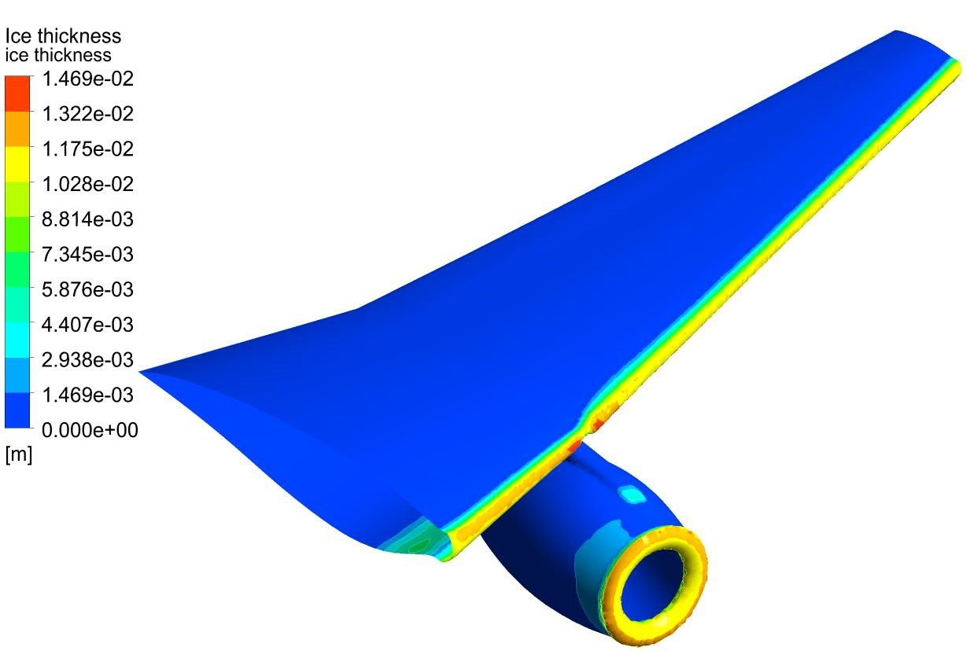

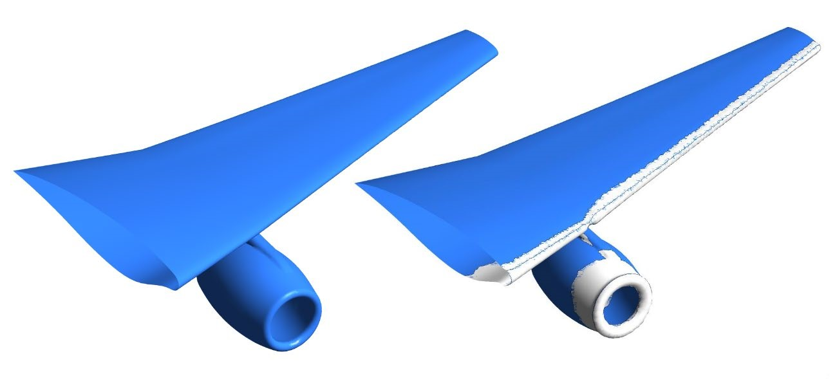

Figure 6: Ice formation and thickness of ice on required surface

# Project: Gas turbine exhaust Diffuser analysis

CAD models for two exhaust diffuser designs were provided and air flow simulation was run using ANSYS CFX. Mesh was made using Workbench inbuilt mesher. Comparison was made by the end user between two designs with the help of output parameters of airflow simulation like lift and drag.

|  |  |
| --- | --- |
|  |  |
|  |  |

Figure 7: Clockwise from top left (a) and (b) velocity streamlines. (c) Pressure contour (d) velocity contours

# Project: Solid flow erosion

Pumping Oil out of well is easier said than done. It passes through a whole lot of different filters to filter out sand. Although these filters filter out sand but at a cost of Pressure drop and Erosion. Erosion is the biggest enemy of these filters and usually a bottleneck to their life as well. Solid flow erosion analysis of two types of filters was performed using ANSYS Fluent. Creo 6.0 was used for CAD modeling of these filters, which were than imported into ANSYS workbench to make mesh using inbuilt mesher and to simulate afterwards using ANSYS Fluent.

|  |  |
| --- | --- |
| *a* | *b* |
| *c* | *d* |

Figure 8: a: Basic structure of both filters b: Two types of filters selected for Analysis c: Configuration 1 CAD model, made using CREO 6.0 d: Configuration 2 CAD model, made using CREO 6.0

|  |  |
| --- | --- |
|  |  |
|  |  |

Figure 9: Clockwise from top left Configuration 1 Pressure Drop contours, Configuration2 Pressure Drop contours, Configuration 1 Velocity Streamlines, Configuration 2 Velocity Streamlines

# Project: Heat transfer analysis of bacterial growth instrument

The client was developing an instrument and consumable to monitor bacterial growth. The bacteria were inserted between two layers of the consumable, placed on the instrument. The consumable is heated/cooled from a distance and growth was monitored by a temperature sensor, millimeters away from the consumable. Bacteria died when too hot or too cold so the temperature proximate to the bacteria required precise measurement and control. Because it was not possible to put a temperature sensing device in direct contact with the bacteria, the client required a thermal model to estimate the bacteria’s temperature.

Geometry of the instrument was provided by the client. Mesh and Analysis was made in ANSYS Workbench Mechanical. It was a complex model with 7 parts in the instrument and 7 sides of the instrument exposed to air for convection. Steady-state analysis was performed to find heat source temperature for the required bacterial film temperature. Transient analysis was performed to measure time to reach steady state results.

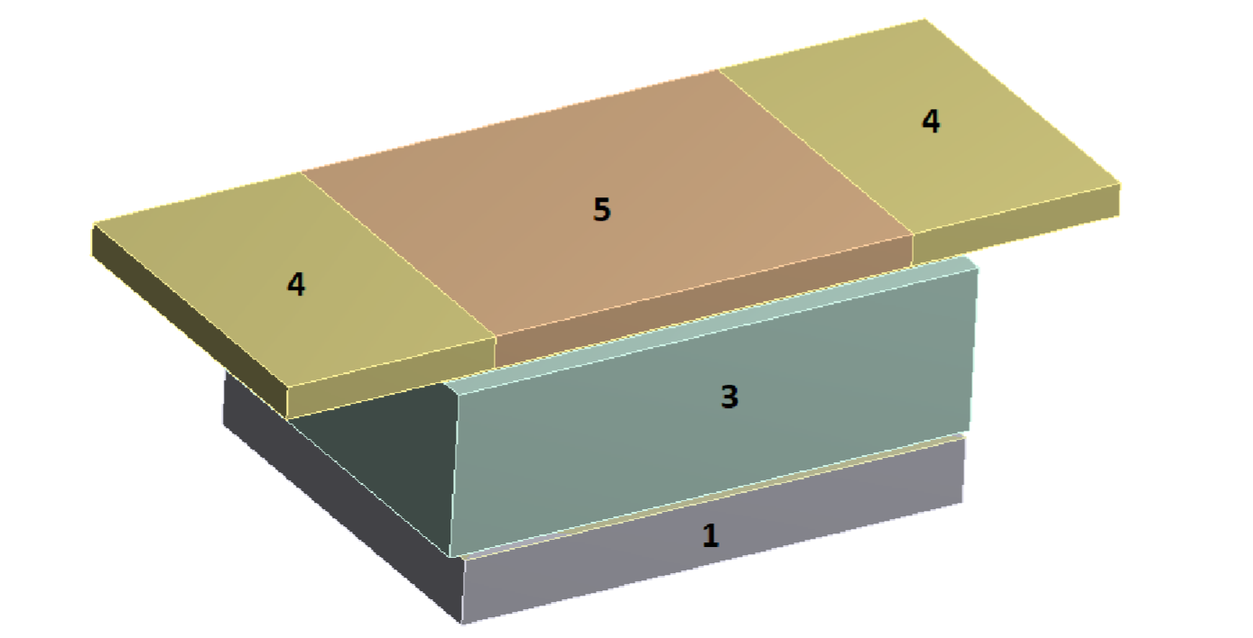

Figure 10: Instrument CAD model. Between 1 and 3 is bacteria film and beneath 1 is the heat source.

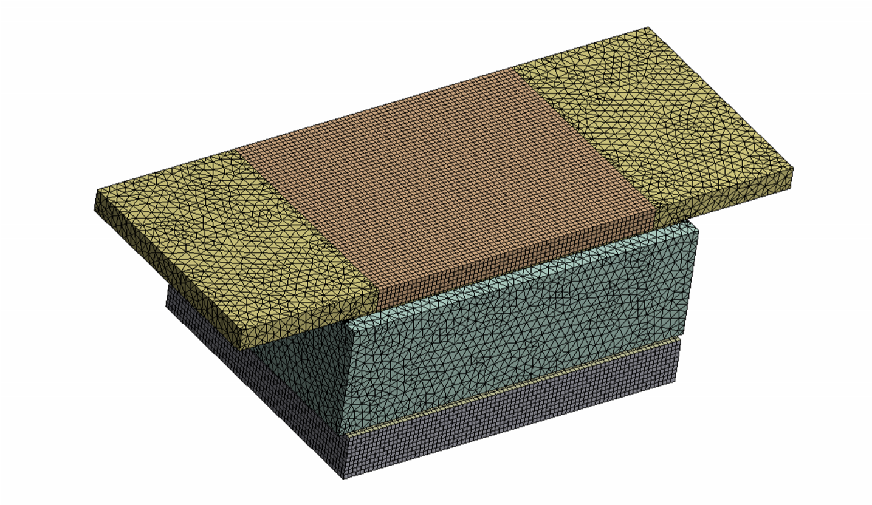

Figure 11: Mesh of the model made using ANSYS inbuilt mesher

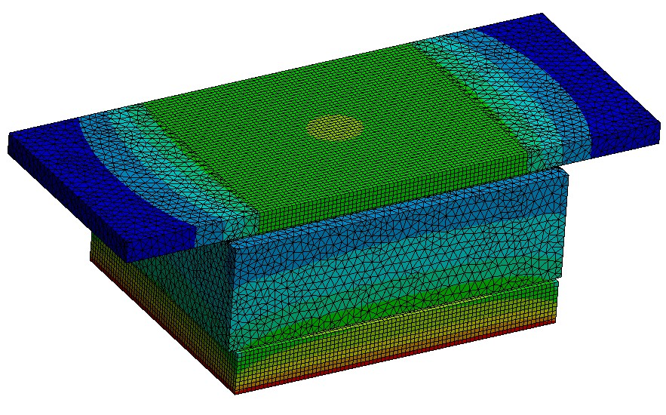

Figure 12: Steady-state temperature contours of instrument.

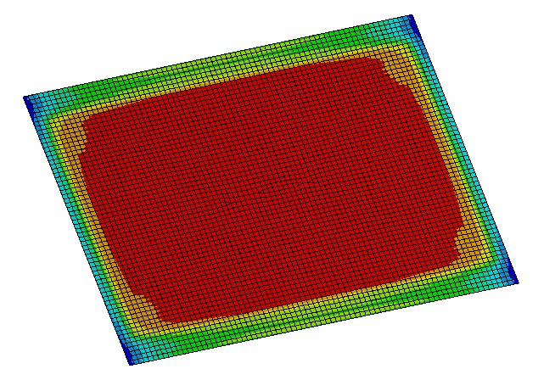

Figure 13: Steady-state temperature contours at bacteria film

# Project: Structural Analysis on Accelerator

A very simple looking yet a challenging project for me. It had to be done in Ansys Composite PrePost (ACP) because of different material properties involved. Composite and aluminum both material properties were used. The analysis was to check the stress and deformation at different force value when applied.

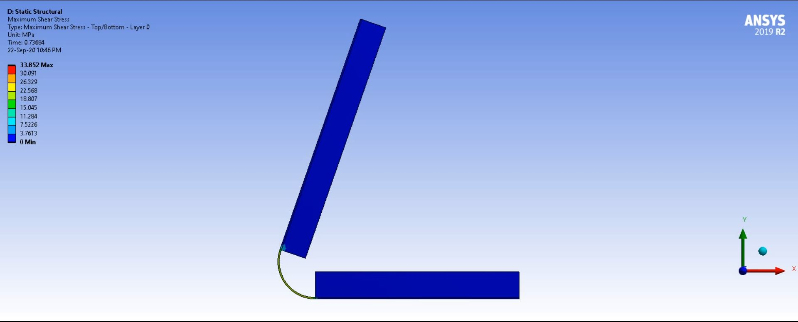

Figure 14: Composite car accelerator

# Project: Sloshing phenomenon using VoF (multiphase)

Simulation of slosh phenomenon may look beautiful and innocent but it is responsible for many truck accidents transporting different liquid types. Using baffles is the most common way of stopping the damaging effects of slosh phenomenon in large liquid tanks.

Simple tank geometry and tank geometry with many types of baffles installed were provided by the client. Mesh was made in ANSYS workbench inbuilt mesher and simulation was run in ANSYS Fluent. Volume of Fluid method (VOF) was used in Fluent which is regarded as appropriate mixture method in situations involving free surface. Transient analysis was performed. A starting acceleration was given to emulate braking phenomenon in transport.

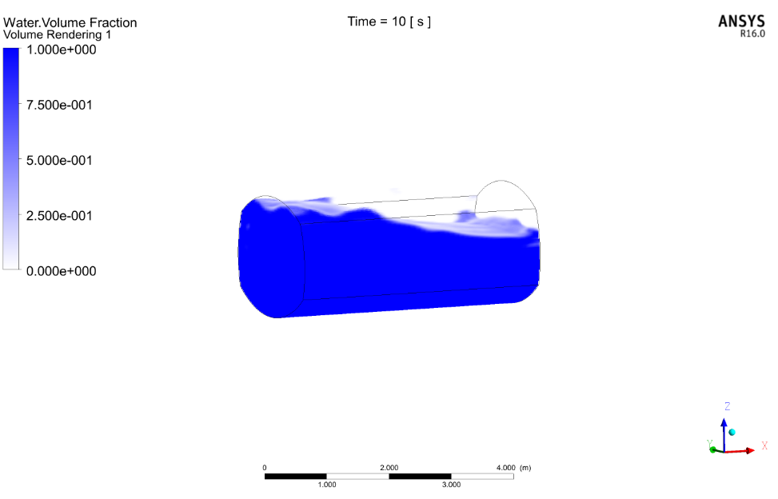

Figure 15: Compartment without baffles

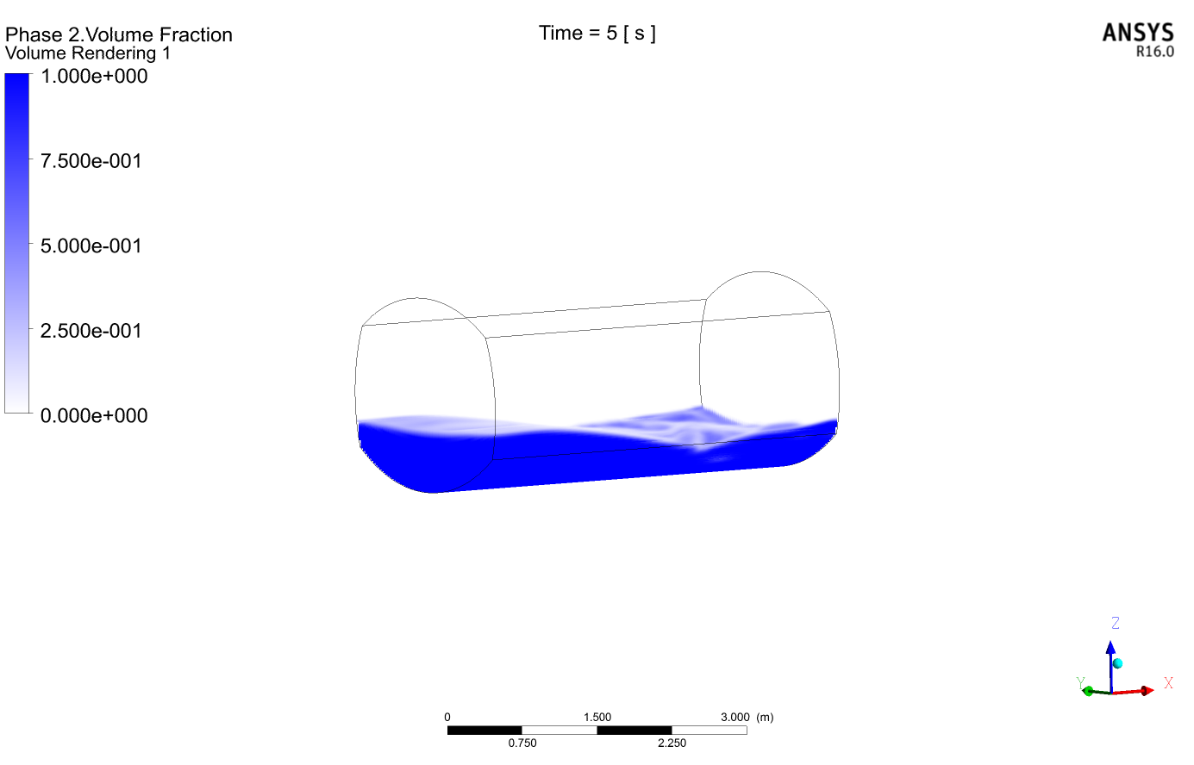

Figure 16: Compartment without baffles

# Project: Cold flow and condensation problem analysis

A condenser design was tested for its working using ANSYS Fluent. Brackish water passed through 25mm copper pipe with stainless steel plates aiding in heat transfer in a condenser. Steam was made to pass over it and condense accordingly.

Drawings and CAD model were provided by the client. CAD model was cleaned according to meshing requirements and mesh was made using ANSYS workbench inbuilt mesher. Steady state solution was run in ANSYS Fluent with Energy equation. This was a multiphase problem so mixture model was used with phase change phenomenon of “evaporation- condensation” selected.

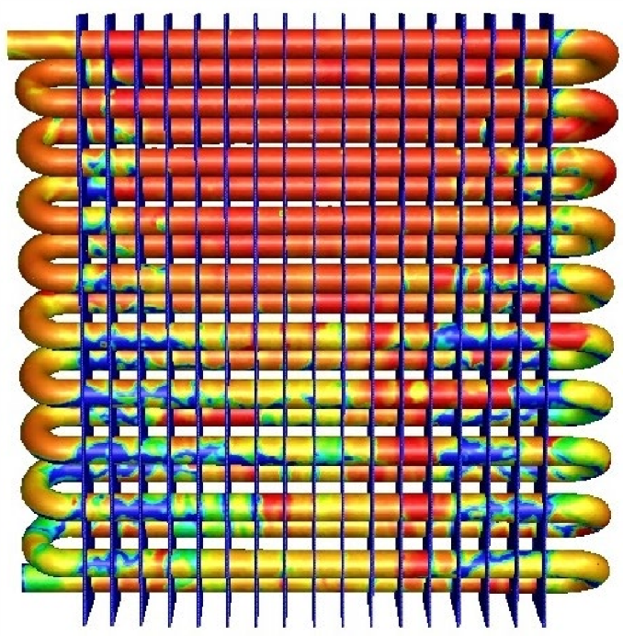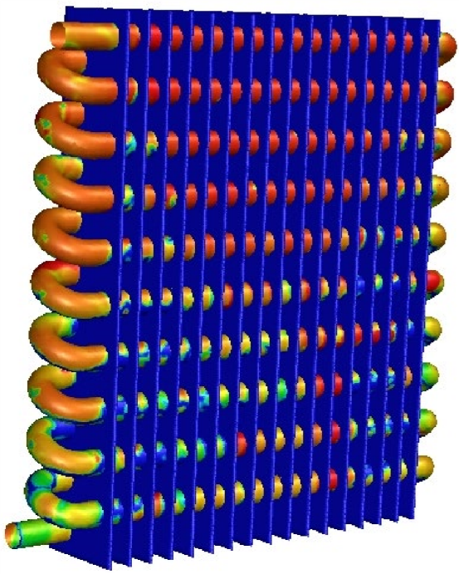

Figure 17: Condensation rate visible, red with most and blue with least condensation rate. Note the increased condensation rate at top center where steam impinges most.

Figure 18: Note the difference of condensation rates between copper pipes and steel plates.

# Project: Wind Turbine Analysis

This project of wind turbine started from simulating one turbine from a reference paper to simulating it in wind farm. Mesh was created in the inbuilt mesher of Ansys workbench. The model was taken from the reference paper and was simulated with 3 different yaw angles. First the model was created and then the mesh sensitivity analysis was conducted. After doing these further research and analysis was done.

The project started from being one turbine and then the next steps involved to have more turbines in such a way that they should be efficient in producing the power. Different yaw angles 0, 5 and 10 were used for different configurations to see which one is best. Some of the pictures of the analysis are given below:

Figure 19: Mesh generated in Ansys of wind turbine. Second picture shows the analysis.

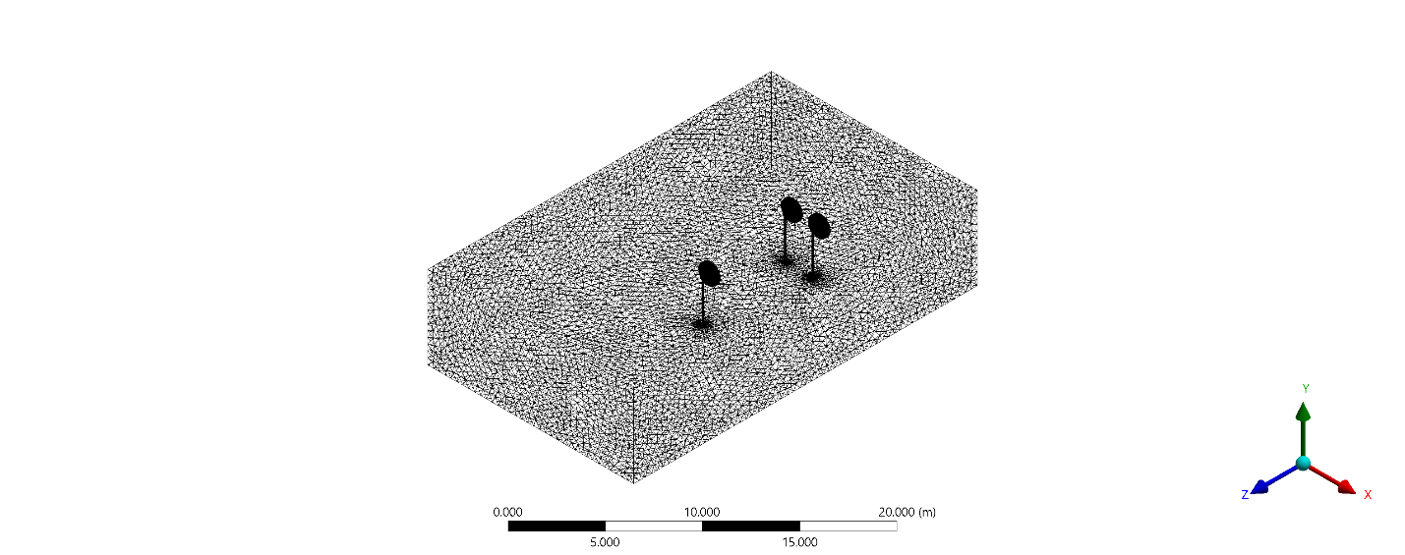 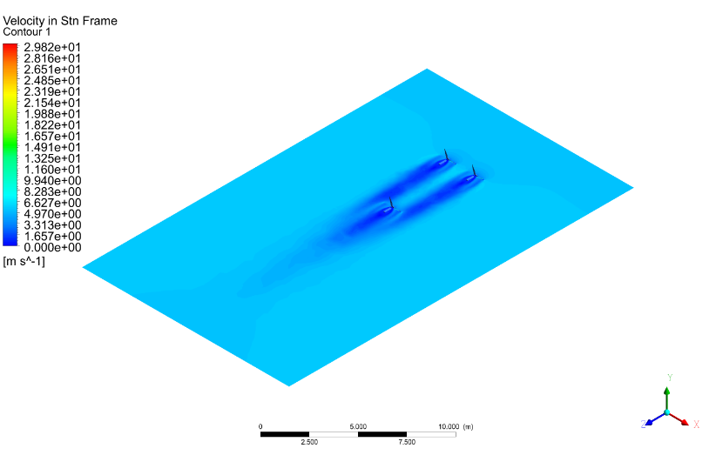

Figure 20: Mesh of 3 turbines along with the velocity contours in the second figure.

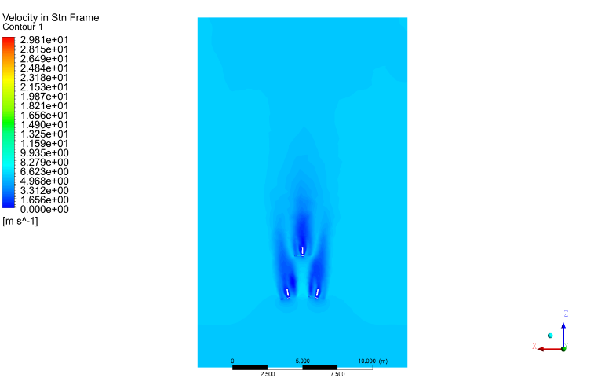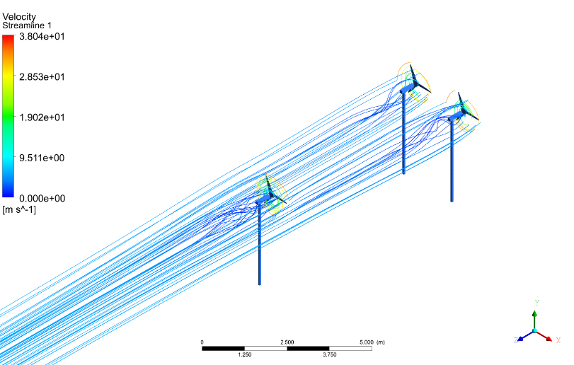

Figure 21: Stream lines of 3 wind turbine at a yaw angle and second figure shows the velocity contours.

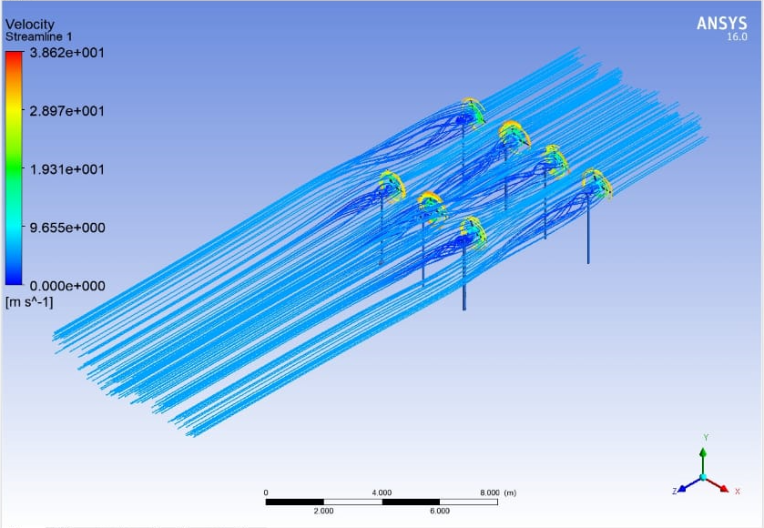

Figure 22: Streamlines of 7 turbines simulated in Ansys

# Project: Quadcopter Analysis

The analysis was for the newly designed propellers by the company. They had different configurations of the propeller starting from 2 blade till 8 blade propeller on their quadcopter. They wanted to analyze which configuration gave them the best left according to their weight configuration.

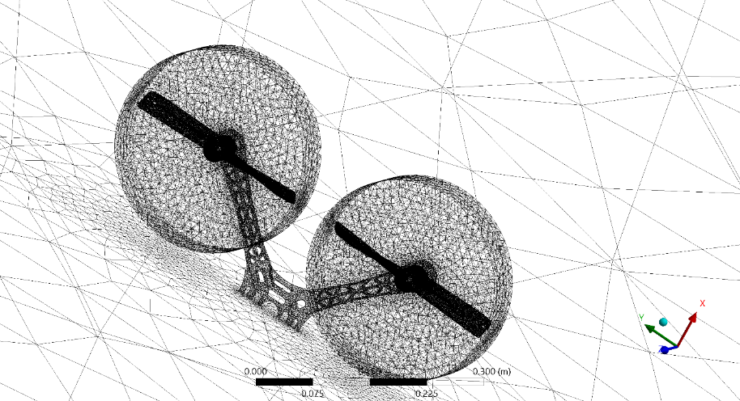

Figure 23: Mesh of 2 blade propeller

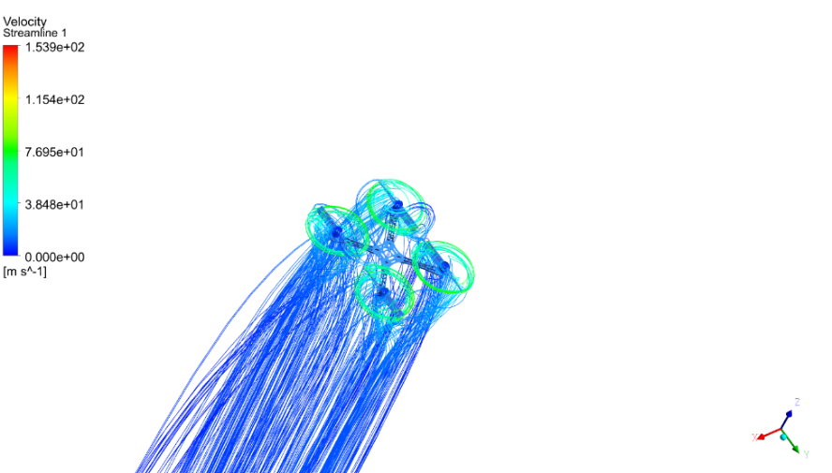

Figure 24: Streamlines

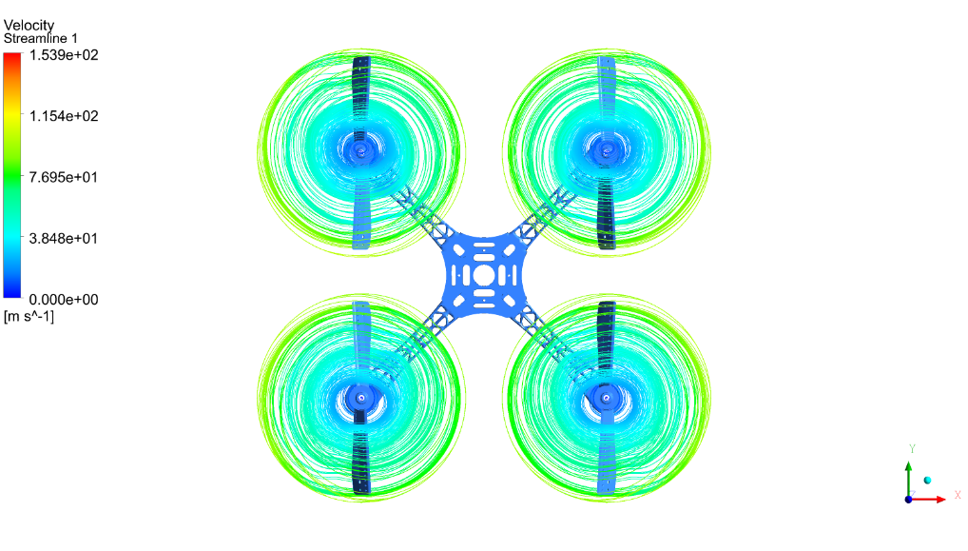

Figure 25: Streamlines along the propeller blade